Dobbyns, Steve (from Linked In)

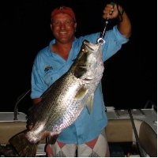

Hurlstone Agricultural High School HSC 1976 – 1981. BSc Forestry ANU 1987.

Timber Merchandising Manager, Hunter Region Forests NSW 1999 – 2005. Acting Regional Manager, Hunter Region Forests NSW 2005 – 2006. Timber Merchandising Manager (Maitland), Central Region Forests NSW 2006. Pricing Analyst, Native Forests and Hardwood Plantations, Commercial Services Forests NSW 2006 – 2007. Timber Merchandising Manager, Central Region Forests NSW 2007. Export Manager Environmental Consultants International 2007 – 2008. State Manager, NSW, Vic and QLD MTX Australia Pty Ltd 2008 –2009. Owner Jamax Forest Solutions 2009 – .

